PRASANNA SATHYAMURTHY

COSC 5360- SPRING 2014

DATABASE DESIGN

ASSIGNMENT-1

**SAMPLE UNIVERSITY DATABASE**

**STUDENT TABLE, FACULTY TABLE, CLASS TABLE and ENROLL TABLE**

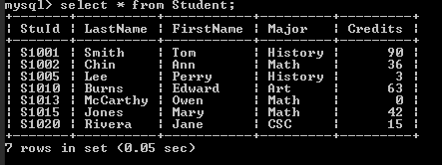

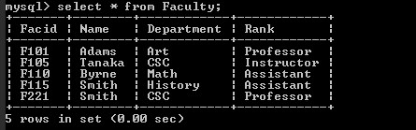

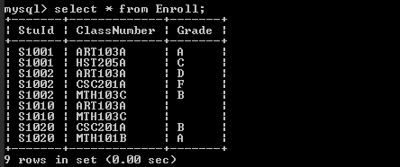

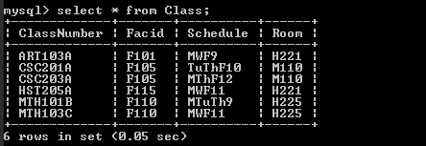

**QUERIES**

**1**. Get Names, ID’s and the number of Credits of all Math majors.

*QUERY🡪* **mysql> select LastName, FirstName, StuId, Credits from Student where Major = 'Math';**

*OUTPUT🡪*

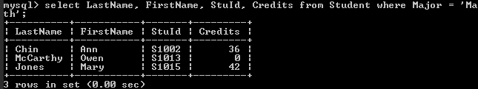

**2.** Get all information about CSC Faculty.

*QUERY🡪* **mysql> select * from Faculty where Department = 'CSC';**

*OUTPUT🡪*

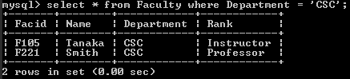

**3.** Get the courses number of all course in which students are enrolled.

*QUERY🡪* **mysql> select ClassNumber from Class where ClassNumber in (select ClassNumber from Enroll);**

*OUTPUT🡪*

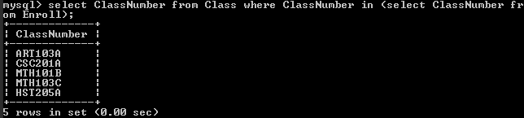

**4.** Get all information about all students.

*QUERY🡪* **mysql> select * from Student;**

*OUTPUT🡪*

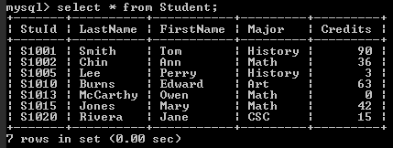

**5.** Get names and ID’s of all Faculty members, arranged in alphabetical order by name. Call the resulting columns FacultyName and FacultyNumber.

*QUERY🡪* **mysql> select Name as FacultyName, Facid as FacultyNumber from Faculty order by Name asc;**

*OUTPUT🡪*

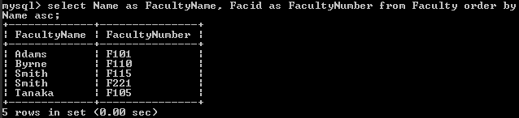

**6.** Get names of all math majors who have more than 30 credits.

*QUERY🡪* **mysql> select LastName, FirstName from Student where Major = 'Math' and Credits > 30;**

*OUTPUT🡪*

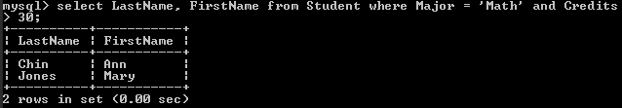

**7.** Find IDs and names of all students taking ART103A.

*QUERY🡪* **mysql> select StuId, LastName, FirstName from Student where StuId in (select StuId from Enroll where ClassNumber = 'ART103A');**

*OUTPUT🡪*

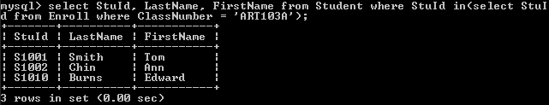

**8.** Find StuId and Grade of all students taking any course taught by Faculty member who’s FacId is F110. Arrange in order by StuId.

*QUERY🡪* **mysql> select StuId, Grade from Enroll where ClassNumber in (select ClassNumber from Class where FacId='F110') group by StuId;**

*OUTPUT🡪*

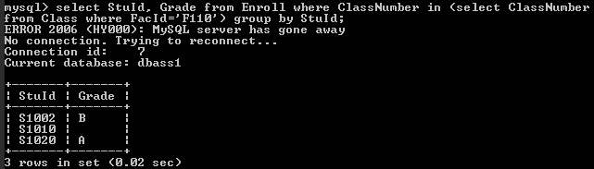

**9.** Find course numbers, names and majors of all students enrolled in the courses taught by Faculty member F110.

*QUERY🡪* **mysql> select enroll.classNumber as Course_Number, stud.firstName as First_Name, stud.lastName as Last_Name, stud.Major from Enroll enroll natural join Class class1 natural join Student stud where class1.facId = 'F110';**

*OUTPUT🡪*

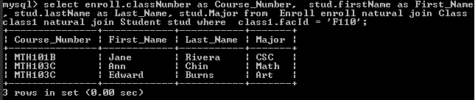

**10.** Get a list of all courses that meet in the same room with their schedules and room numbers.

*QUERY🡪* **mysql> select class1.ClassNumber, class1.Schedule, class2.ClassNumber, class2.Schedule, class2.Room from class class1, class class2 where class1.ClassNumber < class2.ClassNumber and class1.room = class2.room;**

*OUTPUT🡪*

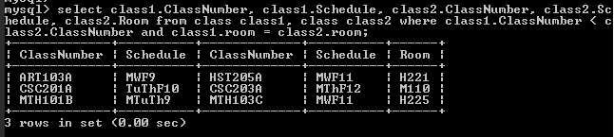

**11.** Find all combinations of students and faculty where the students major is different from the faculty members department.

*QUERY🡪* **mysql> select S.StuId, F.FacId from Student S, Faculty F where S.Major <> F.Department;**

*OUTPUT🡪*

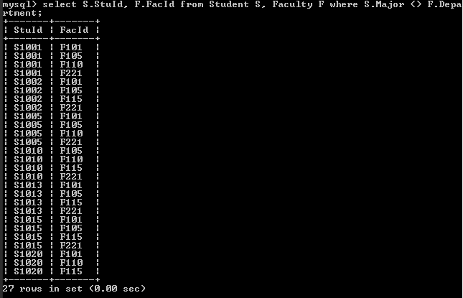

*QUERY 11-* ***CASE:2 [For all combinations of Faculty teaching Students differing from Department and Major]***

**mysql> select fac.facID as Faculty_ID, fac.Department as Fac_Dept, stud.stuID as Student_ID, stud.Major as Student_Major from Class class1 natural join Enroll enroll1 natural join Faculty fac natural join Student stud where fac.Department<> stud.major;**

*OUTPUT🡪*

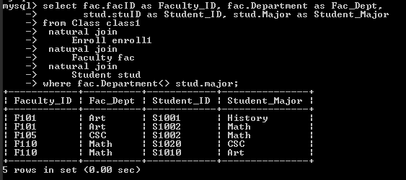

**12.** Find the number of all the courses taught by Byrne of the Math department.

*QUERY🡪* **mysql> select Count(ClassNumber) from Class where FacId in (select FacId from Faculty where Name='Byrne' and Department='Math');**

*OUTPUT🡪*

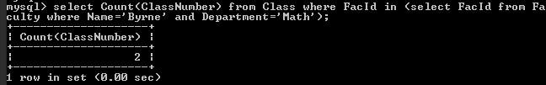

**E-R DIAGRAM FOR THE SAMPLE UNIVERSITY DATABASE**

